**Report**

3) To capture the photographs for my experiments, I used the back facing camera of an iPhone 5 with the HDR turned off and a normal tone. There are no others settings to manipulate. All the images used these same camera settings. In total, I captured six sets of images consisting of five experimental image sets with one normal image set to use as a base.

(Rather than having to label every time, I ordered each image set as follows:

**backA, compA, backB, compB, alphaOut, colOut, compOut**)

***Normal Image***

For the first set of images, I used plain backgrounds and a solid object with no extra light. This is used as a base model to compare with for the experimental images.

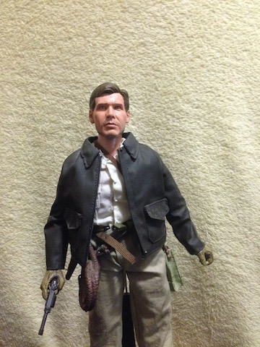

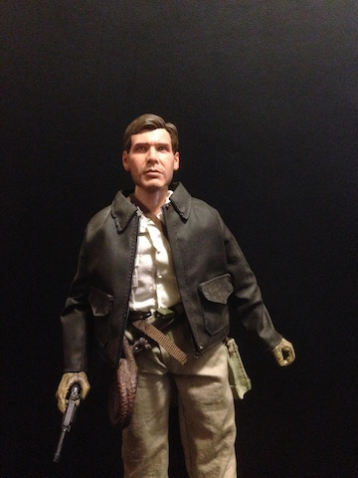



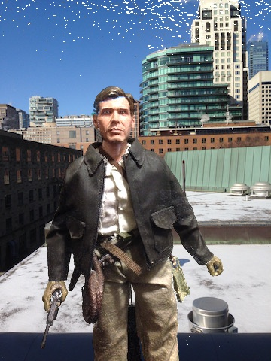

Based on the result images, it seems like my matting algorithm works. There is noise in the upper part of the image, but that is due to uneven lighting which I could not fix.

***Bright light on one side***

I wanted to test the same object and the same background but with extra light, so I shown light on only the left side of the object to check if that would change the alpha image. I used a lamp light. Everything else was left the same.

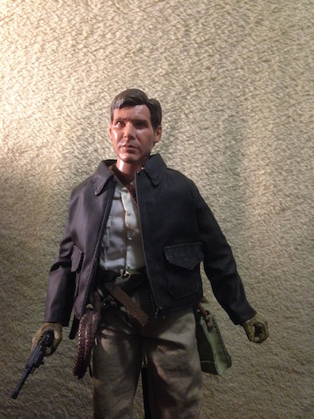

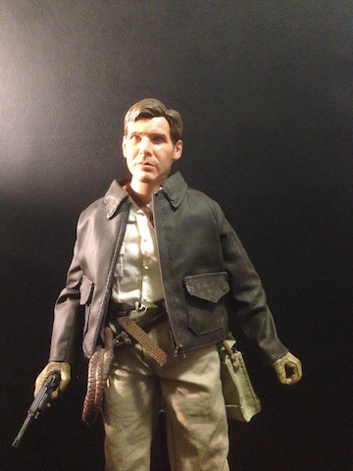

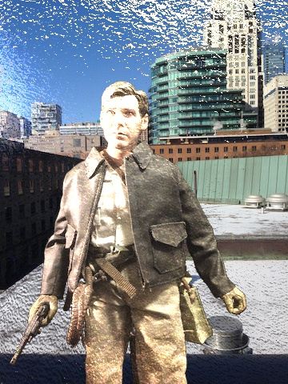

The resulting alpha was almost complete white, which means that most alpha values were 0 which then suggests that the entire object is transparent. The extra light seems to have removed any sort of nuance with the alpha values. The final composite image is uneven and noisy. This experiment has told me that it is best to shoot these images in natural lighting, and it also confirmed the reason for question A4.

***Reflection on steel***

Using the same lighting experiment from the previous set of images, this time I changed the object being used. Rather than using a non-reflective object, I used a reflective object to test conditions under which light will be reflected by the object. The backgrounds are the same as before.

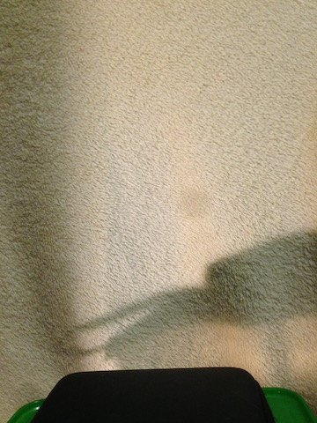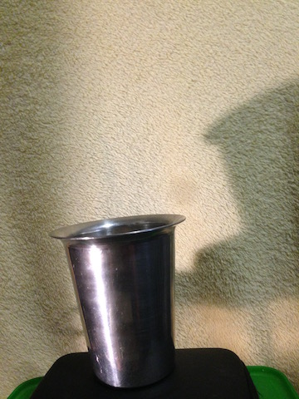

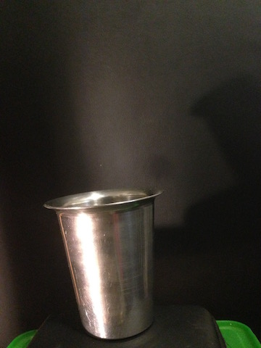



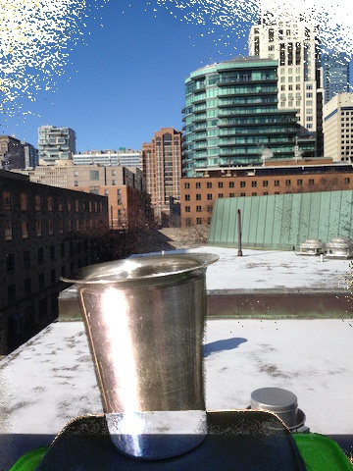

Similar to the previous experiment, the alpha values leave no room for nuance. Most of the them, especially the parts where there is more light, are very close to 0. What I also noticed was that the edges of the object are not very sharp, but this is probably due to the fact that the edges of the glass are darker. This, along with the previous experiment, were successful in revealing a flaw with triangulation matting in that too much light being shown or reflected off the image results in a highly transparent object. Natural lighting will make the final composite image look as natural as possible.

*Glass see-through*

For this experiment, I wanted to test if a completely see through object like clear glass would be able to create a composite image. For the object, I used a glass without any water or extra light. The background is left the same. Based on the strengths of triangulation matting, the object in the composite image should be see-through, which meant that the object’s alpha values should float closer to 1.0.







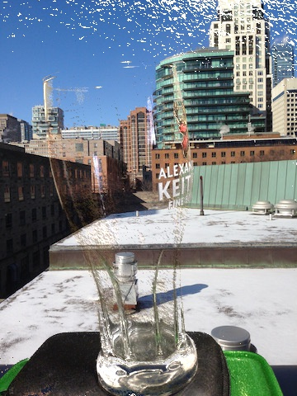

Based on the alpha image and the composite image, it seems like this experiment was a success. Triangulation matting works well under clear see-through conditions.

***Refraction:***

Using the same object from the previous experiment, this time I filled the glass with water to test refraction. Will the object in the final composite be able to refract the window background? Or will the water be treated like air? The background is left the same and there is no extra light shown.

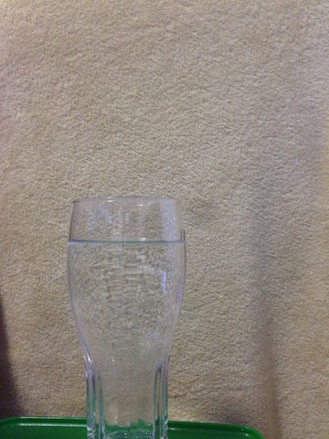

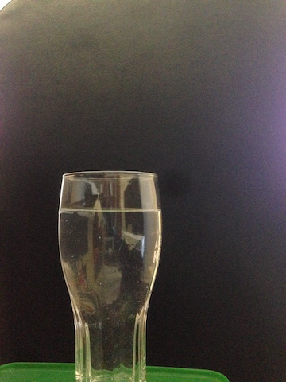



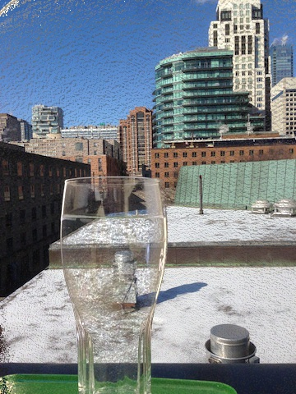

Here, the experiment seems to have failed as the light was not refracted through the water. The window background in the final composite image is not refracted. It is as though there is no water in the glass. Refraction is one of the limits of triangulation matting,

***Patterned background***

This time, rather than changing the object, I changed the background. I switched out one of the plain backgrounds and used a patterned background to test how much the resulting composite would change. The object is non-reflective and opaque.

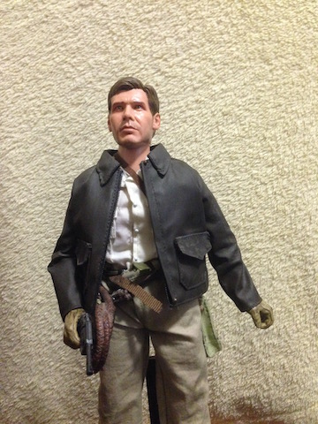

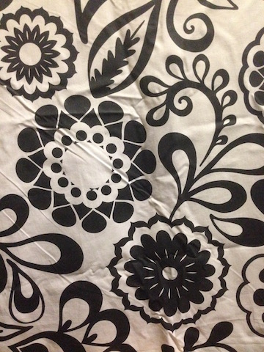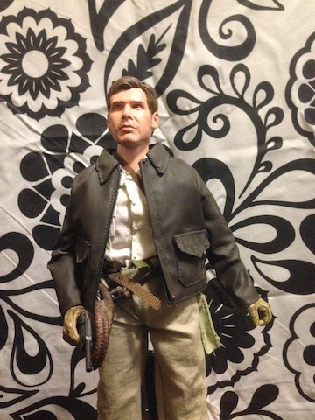



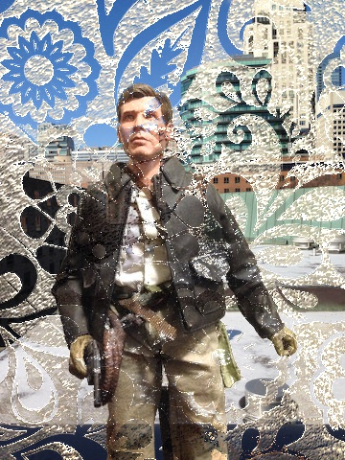

Based on the resulting images, I conclude that triangulation matting does not work with patterned background. The algorithm saw the patterns as part of the foreground object, which is why the patterns are part of the alpha and the final composite. The algorithm only works with plain backgrounds because it is easier to differentiate the foreground from the background.

4) The Alpha values on the left side of the image are not 0 values because the light on that side is not very intense or bright. If we observe the original composite images, we can notice that there is more light on the right side and the vase is slightly darker on the left. This, along with the fact that one of the background colors is black, can be confusing to the program which might assume that the left side of the vase is part of the dark background. This is actually one of the limitations of triangulation matting. The low intensity of the RGB values for the foreground images on the left side will result in slightly higher than 0 alpha values. There will be more anti-aliasing. Therefore, will result in non-zero Alphas towards the left side. The experiment in which I shown light on one side of the object can be used to confirm this idea. The alpha values were mostly 0 in the areas of more light as it provided more contrast to the background. The edges were closer to 1 as it blended in to the darkness of the background more.

5) For the moving foreground image, we can look at it frame by frame. In order to place the foreground image in front to two background images like the assignment, perhaps we can change the background color for every frame. So on one frame, the background is white, and the next its black, and repeat. The object in the two consecutive frames would look identical in terms of placement.